OP ART

Optical Art

***Op Art originated in the 1960's. It was first called “kinetic art” (art which moves) because some of the art actually moved or appeared to move because of the way the designs play tricks on our vision.***

***The visual effects use color and patterns that disturb the eye and cause it to see images or movement on a flat surface.***

***Victor Vasarely is considered the father of Op Art. Vasarely explored visual illusions, and combined geometric elements with color and value to result in optical illusions.***

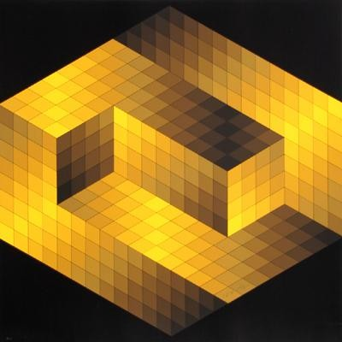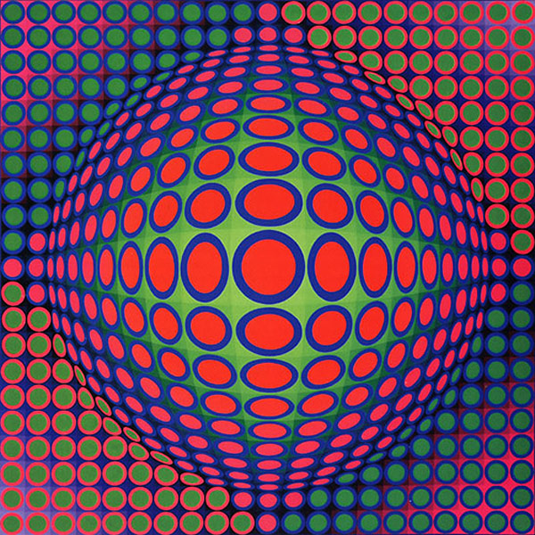

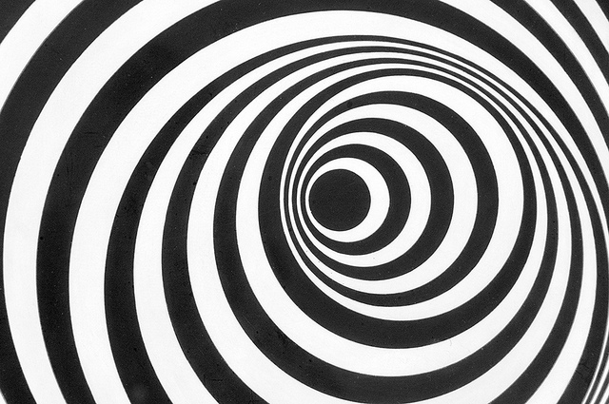***One of the most effective Op Art illusionists is Bridget Riley. Her work includes black and white linear work which makes her pictures appear to wave.***

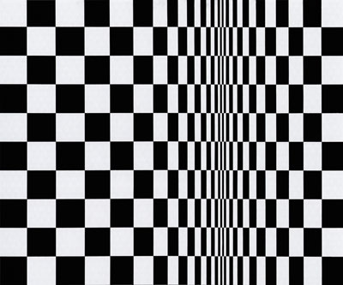

Contour line hand

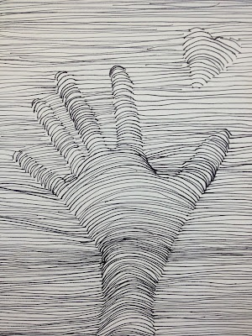

1. Very lightly trace your hand
2. In the hand shape draw a series of lines curved in the same direction from one side of the fingers, thumb and palm to the other
3. Outside of the hand shape, continue the lines horizontally

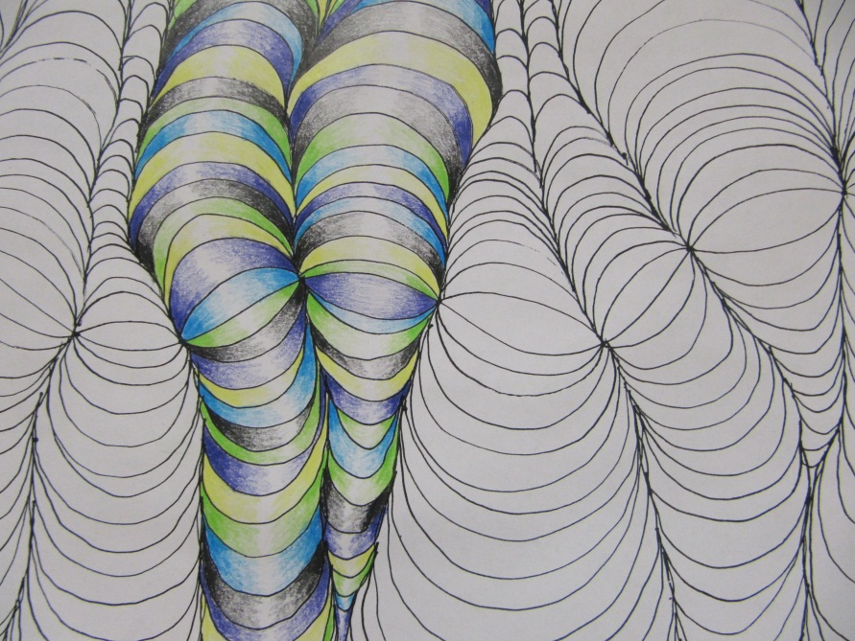

Op art Vertical Lines

1. Draw 7 wavy but not zigzag vertical lines
2. Draw a wavy horizontal line connecting the vertical lines
3. Draw echoing curve lines between each vertical line. The curves above the horizontal line should be curved up in the center and the curves below the horizontal line should be curved down in the center.
4. Make alternating colors and values in a color scheme we have learned in class.

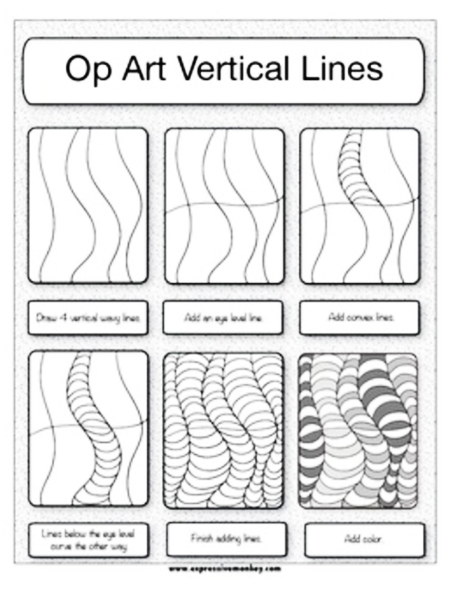

OP Art Converging Lines

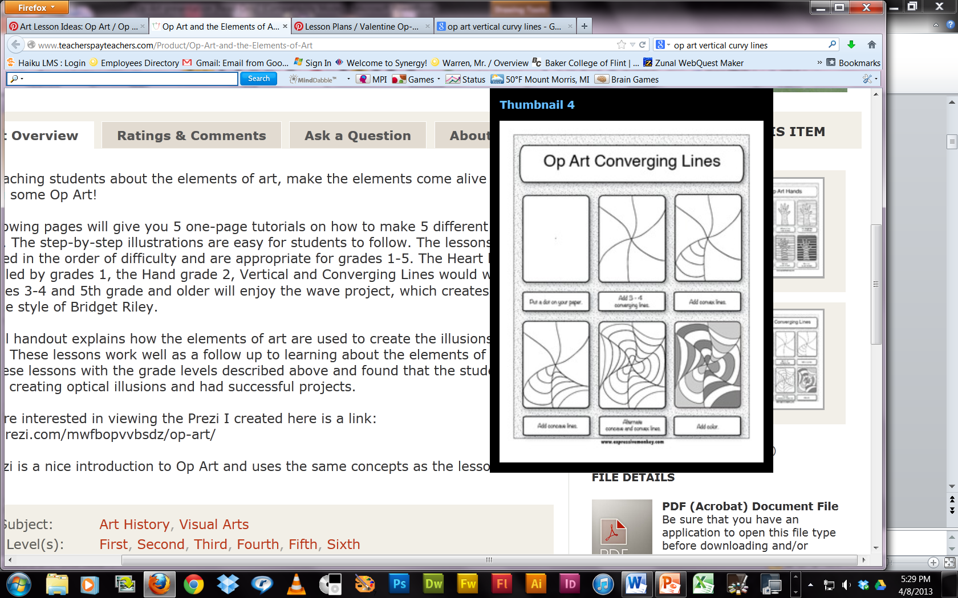

1. Draw three evenly spaced lines lines that cross each other across the page
2. Draw echoing concave lines in one section.
3. continue the lines in the next secotion, but make them convex. Curve them the other way.
4. Fill each section with atlernating concave and convex echoing lines.
5. Alternate light and dark colors so that each light space is only next to dark and vice versa.

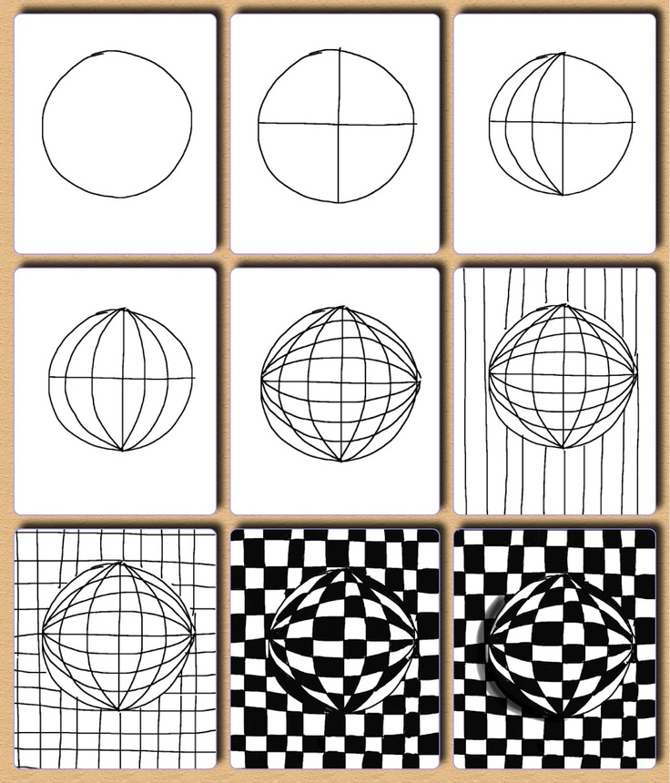

Distorted Checkerboard

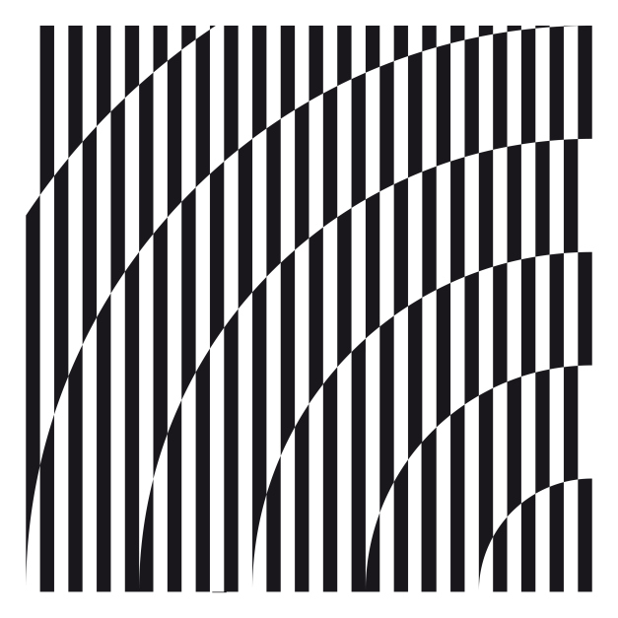

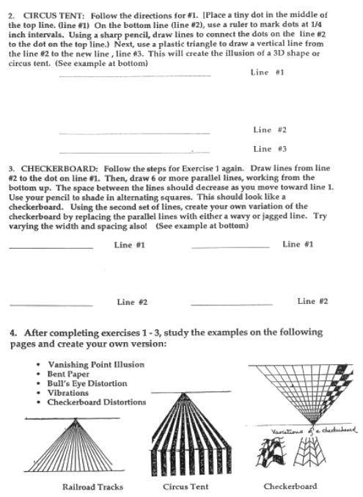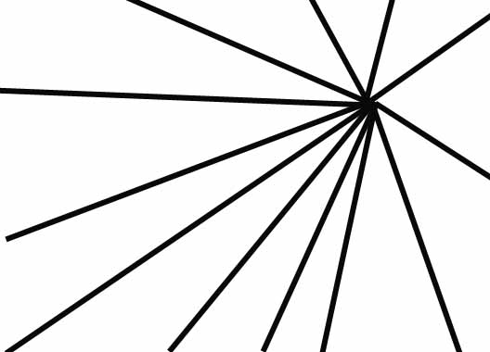

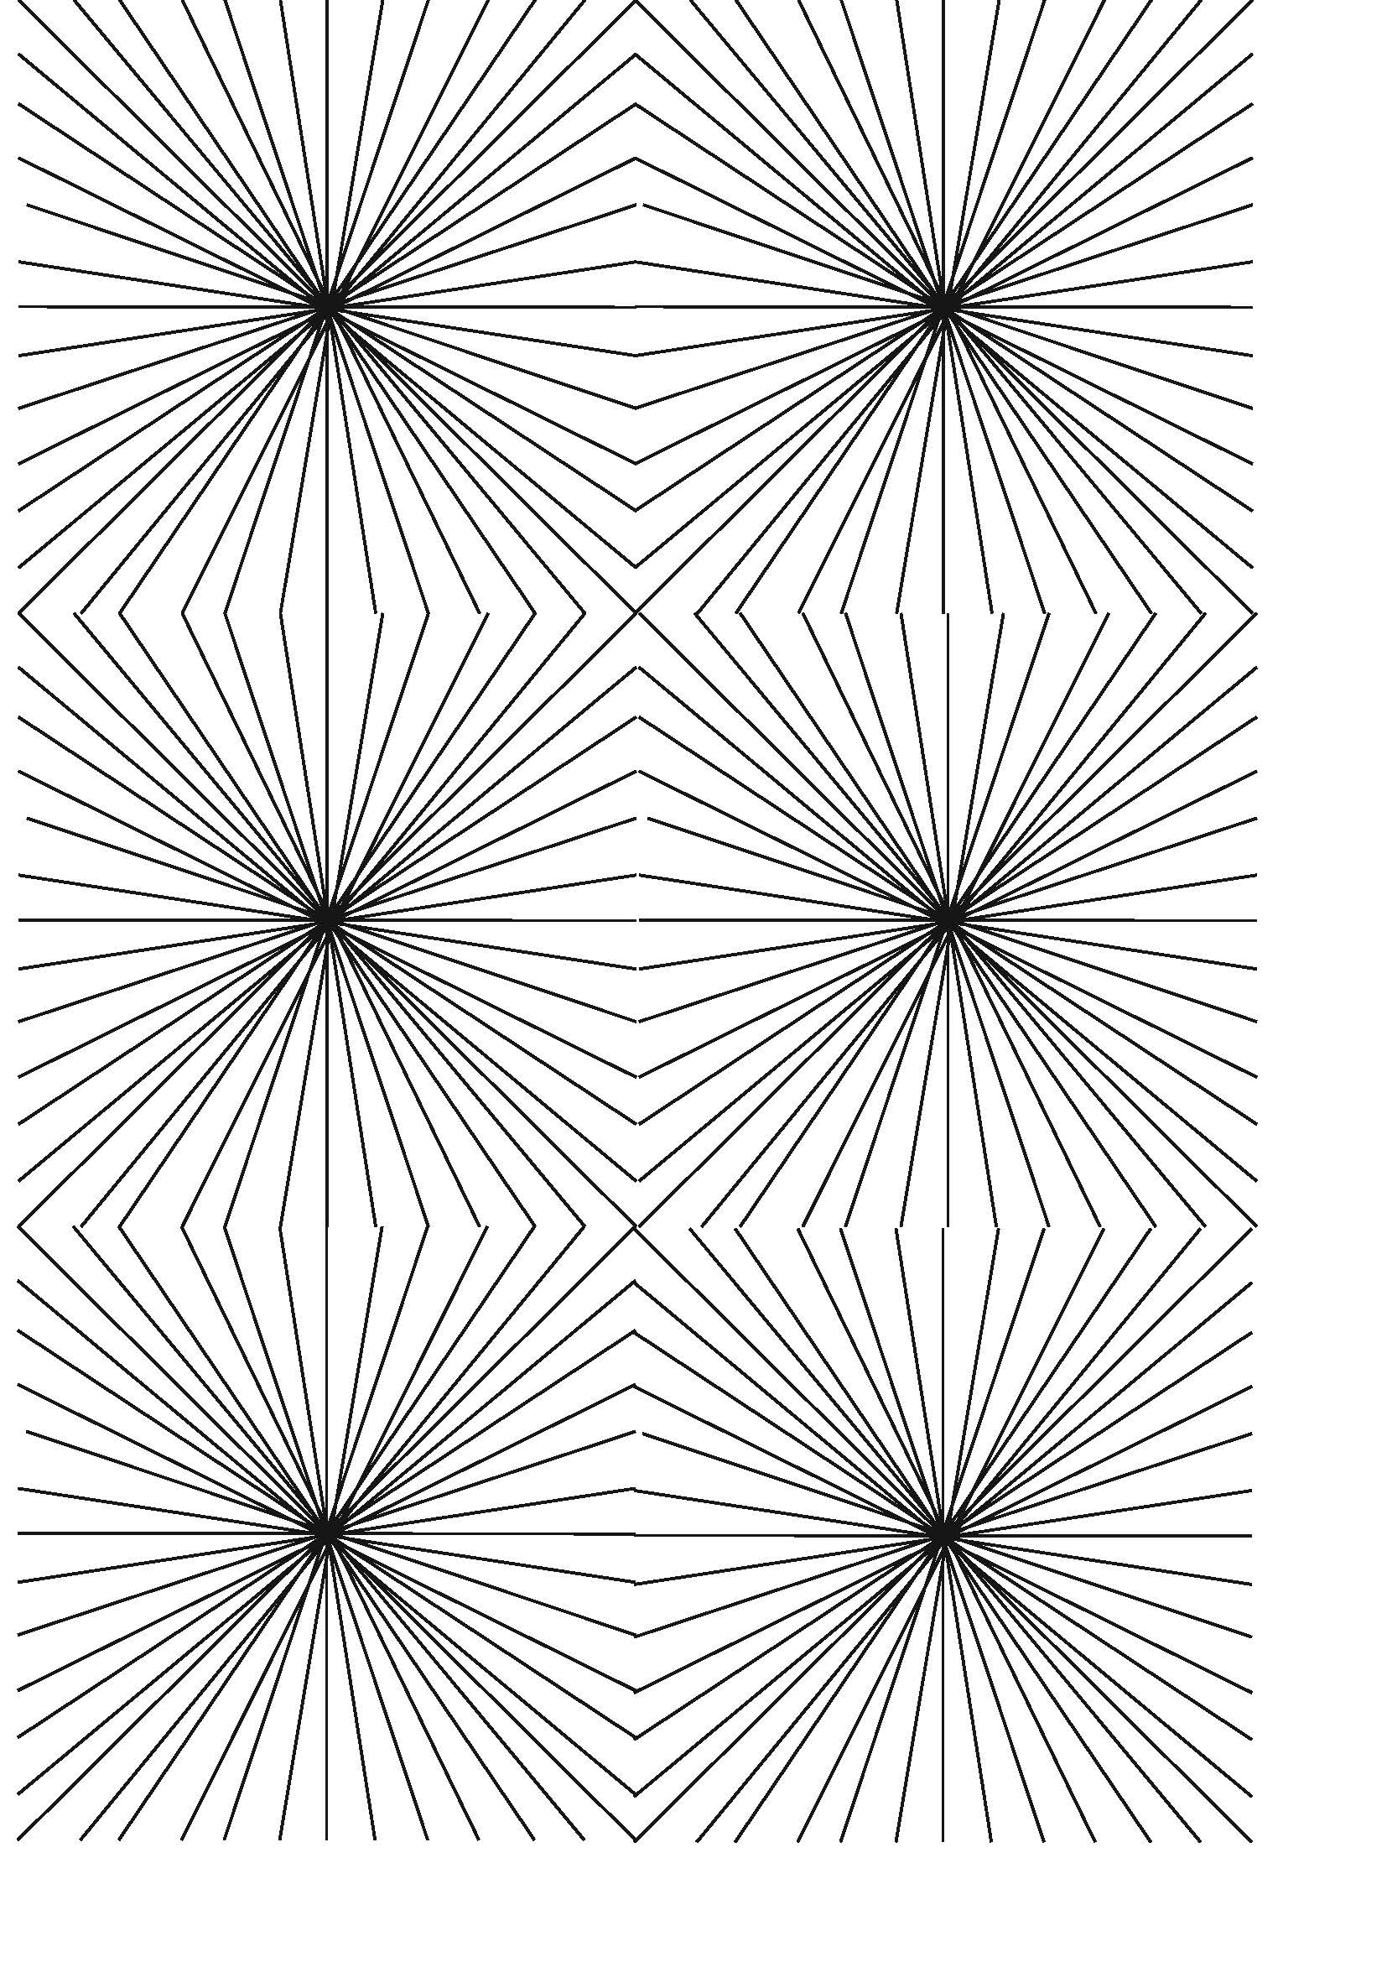

|  |  |  |
| --- | --- | --- |
| Practice Vanishing point illusions |  |  |

|  |  |  |
| --- | --- | --- |
| Distorted checkerboard |  |  |
| Vertical Lines |  |  |
| Converging Lines |  |  |
| http://www.instructables.com/files/deriv/FDB/UQ9A/GB3W2DTV/FDBUQ9AGB3W2DTV.LARGE.jpg |  |  |

Study and re-create these examples

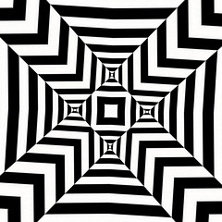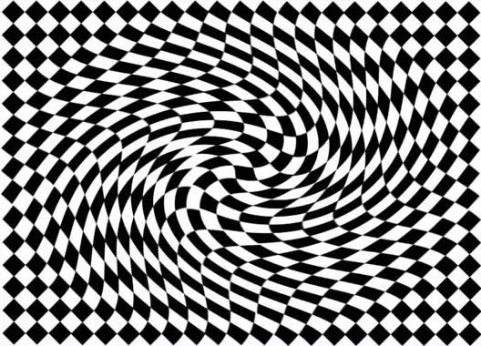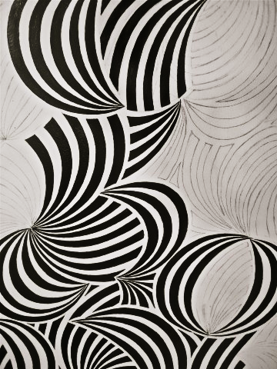 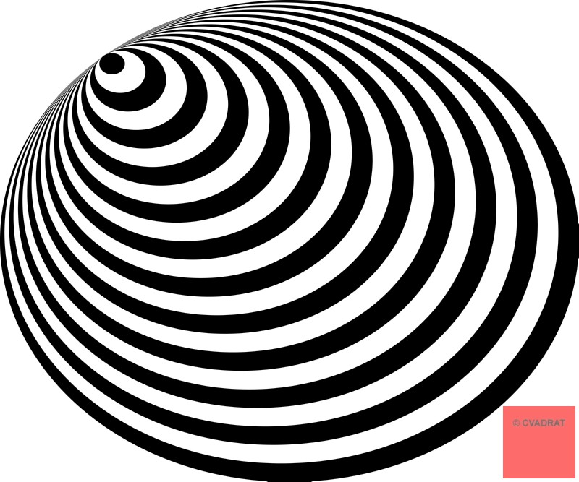

Distorted Bull’s-eye